DESIGN AGENCY

AIM: DESIGNING A DESIGN AGENCY APP

PROCEDURE:

FIRST FIND THE CORRECT DESIGN SCHEME FOR THE AGENCY

CREATE THE DESIGN BASIS WITH FIGMA

USE PLUGINS LIKE FREEPIK,ICONIFY FOR THE ICONS AND THE PICTURES

PROTOTYPE THE DESIGN AND SAVE THE FINISHED PRODUCT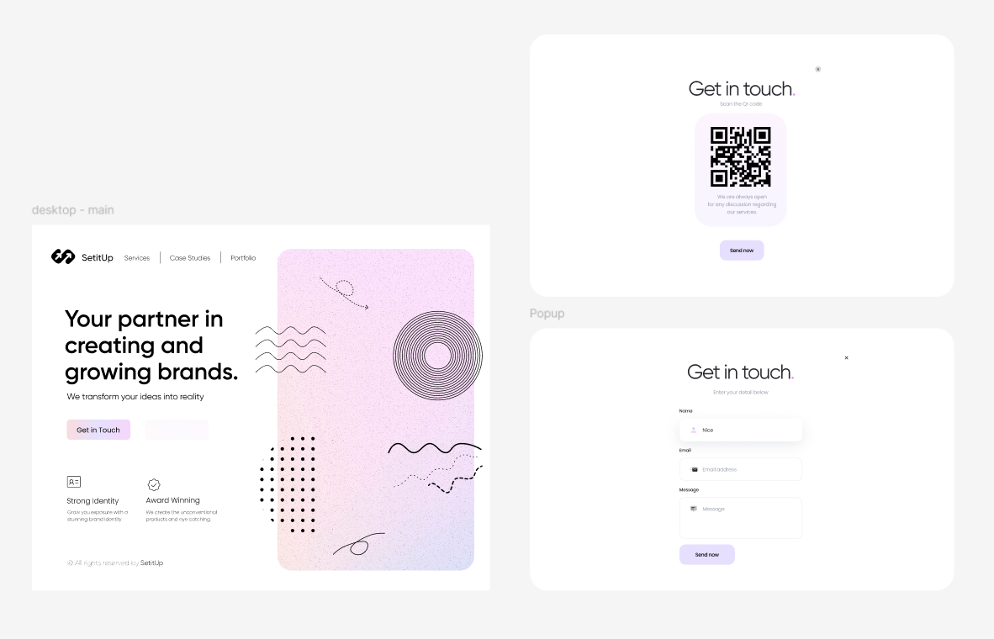

RESULT:

THE DESIGN HAS BEEN SUCCESSFULLY CREATED

RESULT: